GLOBALG.A.P. is a farm assurance program, translating consumer requirements into Good Agricultural Practice..
When you implement the GLOBALG.A.P. standard, with assessment and inspection from ICERT, you will have access to wider markets and will ensure food safety for your customers, and end consumers.
GLOBALG.A.P. signifies the safety and sustainability of your produce.
Whether you are an independent farmer or part of a group with a management structure, Icert can assess and certify your business systems and processes against the GLOBALG.A.P. standard.
Achieving GLOBAL G.A.P. certification will deliver many advantages.
For example, you could benefit from:
1- Enhanced food safety management systems on your farm.
2- Demonstrable commitment to producing and trading safe food.
3- Acceptance into the GLOBALG.A.P. community.
4- Increased consumer and customer confidence in your product safety and quality.

The GLOBALG.A.P. standard is a partnership between agricultural producers and retailers to establish a set of widely accepted certification standards and procedures for good agricultural practices (GAP).
Its scope currently covers fresh fruit and vegetables
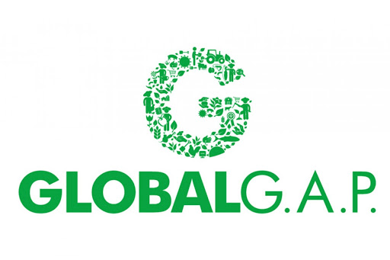To access new markets and demonstrate your commitment to food safety and sustainability

